DSA 210 TERM PROJECT FINAL REPORT
  - EDA DEMİRCİ 34414

Project Title: The Data Behind Smoking Habits

● Abstract
This study investigates the complex relationship between smoking habits, public health outcomes, and national economic indicators across various countries. By integrating multiple datasets covering death trends, health metrics of individuals, e-cigarette prevalence, and national healthcare expenditures, this project employs data science techniques to uncover patterns of tobacco consumption. Through exploratory data analysis and predictive modelling, including Linear Regression, the study explores how smoking rates correlate with healthcare costs, mortality, and socio-economic factors such as education and income levels.

● Motivation
As someone who grew up in a family where no one smokes after harrowing losses in some family members, the topic: "smoking" really gets my attention and I am curious about its general effects. Especially when we started university, my whole entourage slowly started to smoke and try newly e-cigarttes. My personal observations show that my smoker friends' exercising performances (such as running or fitness), immunity, even voices are worse from others. In addition to personal reasons, smoking habits is a truly comprehensive topic which can be investigated in several aspects. For this reason I thought that this would be a suitable topic to see with data visualization and use in my term project.
● Data Sources Used
To conduct a comprehensive analysis, I utilized several publicly available datasets from trusted global sources and Kaggle. Each dataset represents a different dimension of the issue:
- Smoking vs. Health Comparison (1924-2023): Tracks long-term trends in smoking-related deaths across various demographics.
- Individual Health Data: Contains specific health markers (systolic blood pressure, BMI, fasting blood sugar, etc.) for smokers and non-smokers.
- E-cigarette Prevalence: Covers awareness and usage rates of e-cigarettes in 14 different countries.
- Features of Smokers: A comprehensive data showing some physical, health related features such as fasting blood sugar, HDL, LDL. This data focuses only on smokers.
- Smoking Rate 2025: Provides the most recent projections and current prevalence of smoking across all countries, used as the primary independent variable for economic analysis.
- Adult Mortality by Country: Contains longitudinal data on adult mortality rates ($15-60$ years) per $1000$ population, allowing for a comparison between smoking trends and general life expectancy risks.
- Obesity Index by Country: Tracks the prevalence of obesity among adults. This dataset was used to compare the health impacts of smoking against other major global health risks.
- Air Quality and Respiratory Deaths: Provides critical environmental context by tracking PM2.5 and PM10 levels across various countries and years. It includes statistics on total deaths and specific deaths attributed to particulate matter (PM). Including this data allows the project to analyse smoking not in isolation, but alongside environmental factors. It helps determine whether respiratory mortality in certain regions is primarily driven by smoking habits or aggravated by poor air quality.
- Country Income and Education Level: Categorizes countries based on their Education Index, Education Level, and Income Level (High income, Low income). By integrating this, the analysis shifts from purely clinical to socio-economic. It enables the study to explore the correlation between a nation’s education level and its smoking prevalence, testing the hypothesis that higher education and income levels may lead to more successful tobacco control and health awareness.
- Annual Healthcare Expenditures: Contains data on how much is spent on healthcare per person (per capita) annually. The values are adjusted for Purchasing Power Parity (PPP) in international dollars, which allows for a fair comparison of spending between countries by accounting for differences in the cost of living and inflation. Later on a hypothesis will be tested to see if there is a correlation between expenditure level and high smoking rates for a country.
- Bloomberg Global Health Index: Incorporates global health indices, obesity rates by country, and air quality data to account for environmental factors.

● Project Process
This project began with a personal curiosity: Does smoking have broader effects than we know on our lives or countries? I wanted to explore this question not just through intuition or ideology, but through empirical evidence. That’s why I came up with this project idea.
Then, I collected five publicly available datasets from trusted global sources like, Bloomberg, Kaggle, WHO etc. Each dataset was selected to represent a critical dimension of individual features of smokers, country based, well-being and environmental. The goal was to combine both country-based indicators (like education, income, expenditure) and individual indicators (like obesity, mortality and medical values).
After collecting the data, I wanted to make the data extracted from redundant information or non-existing values, that is why I applied:
Data cleaning and Processing:
  - Health metrics were standardized (e.g., splitting blood pressure into systolic values).
  - I changed some columns name to look neat in plotting.
  - I removed irrelevant columns that will be useless for me in my research.
  - Missing values in socio-economic datasets (Education Index) were handled, and categorical variables like smoker status were encoded.
  - I sorted some of the datasets in ascending/descending order where I wanted to plot top countries or lowest.
  - Numerical values were extracted from string-based obesity datasets for longitudinal analysis.
Exploratory Data Analysis (EDA):
  - Helped me to compare groups.
compare different datasets.
  - Correlation matrices were generated to identify relationships between smoking rates, obesity, and healthcare spending.
  - Explore correlations between indicators.
  - Visualizations were used for all datasets in order to understand the distribution of smoking-related deaths and health features like haemoglobin and LDL levels, difference between smokers and nonsmokers, expenditure trends, air quality distribution.
Hypothesis Testing:
  - I have tried to perform hypothesis test on most of my histograms too see if there is an impact of smoking on to that related topic (which I am an investigating in this project) as H1 and a null hypothesis as H0 which claims “there is nothing going on”.

Machine Learning & Modelling:
  - A linear regression model was developed where I have yearly based trending data. This model predicted future healthcare expenditures, obesity levels and death rates.
  - R-square scores were calculated to evaluate the model's success in predicting economic impact across different countries.
● Findings
The analysis yielded several significant insights:
Trend Analysis: Smoking-Related Deaths Over Time
Time-series plots show an upward trend in the number of deaths caused by smoking globally. While the rate of increase varies across regions, the overall pattern suggests that smoking continues to be a growing public health burden. This result supports the alternative hypothesis and underscores that reductions in smoking prevalence do not immediately translate into lower mortality due to long-term health effects.

Comparison of Health Indicators: Smokers vs. Non-Smokers
Across all examined metrics, smokers consistently showed higher average heart rate, cholesterol levels, and systolic blood pressure compared to non-smokers. These results provide empirical support for the health risks of smoking.

Comparison with Ideal Health Benchmarks
Most smoker distributions lie well above recommended levels, particularly for cholesterol and blood pressure. This suggests that smoking not only worsens health outcomes relative to non-smokers but also pushes individuals further away from clinically healthy ranges.

Smoking and Air Pollution at the Country Level
Scatter plots and correlation analysis reveal a connection between a country's air quality and total death rate. Countries with high smoking rates tend to cluster at higher pollution levels, suggesting overlapping public health and environmental challenges. While this analysis does not establish causality, it requires some broader analysis, some missing details to reach a certain claim.

Smoking and Obesity Prevalence
Many high-smoking countries also ranking high in obesity prevalence. This result challenges the common misconception that smoking and obesity move in opposite directions and instead suggests that unhealthy behaviours may meet at the population level.

Cross-Country Comparisons
Ranking countries by smoking prevalence, mortality, pollution, and obesity revealed that the same countries frequently appear in the top tiers across multiple risk indicators. This clustering suggests that smoking is embedded within larger socioeconomic and public health contexts rather than acting as an isolated behaviour.
1-Bar Charts
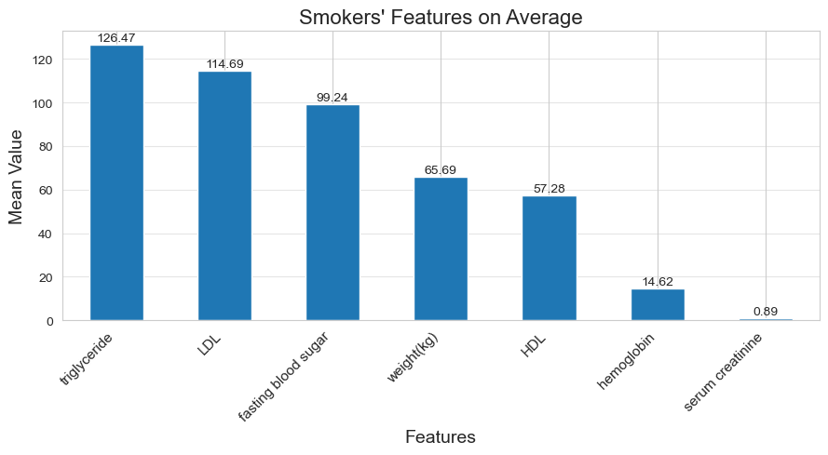
I used a bar chart because it compares different biological markers (lipids, blood sugar, weight) on a single scale to show which "mean values" are highest among smokers. Some key observations are Triglycerides (126.47) and LDL (114.69) show the highest mean values among the biomarkers. Serum creatinine is the lowest (0.89). This chart shows the cardiovascular and metabolic profile of an average smoker, highlighting elevated cholesterol and triglyceride levels.

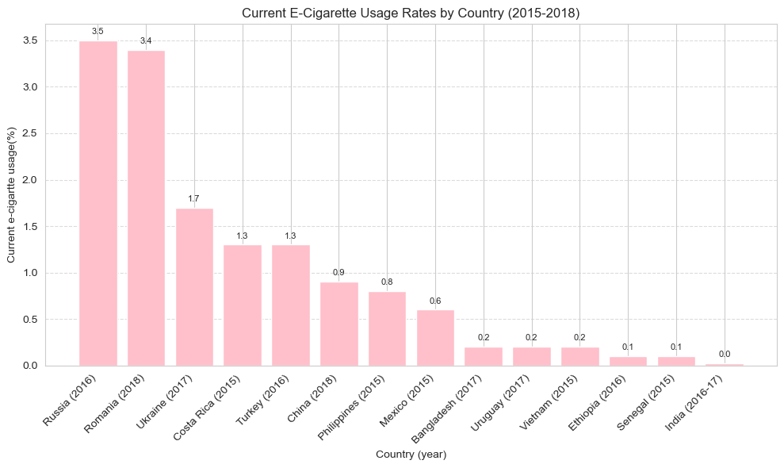
In this part I am investigating the adoption of a relatively new habit (vaping) across different years and regions. It can be concluded that Russia and Romania lead the list, though the overall percentages (max 3.5%). Many countries like India and Senegal show near-zero usage during this period. E-cigarette usage was emerging primarily in Eastern Europe and parts of the Americas during this timeframe, with very low penetration in Asia and Africa.

- 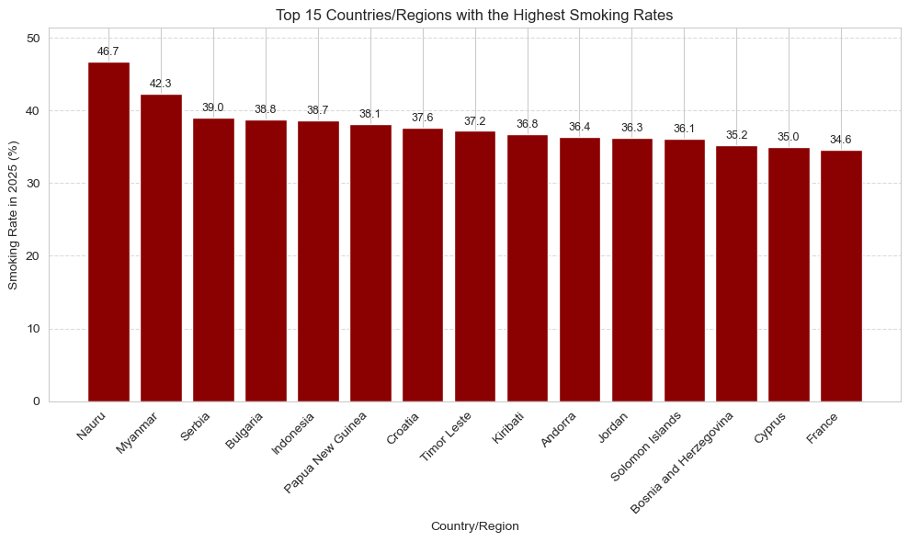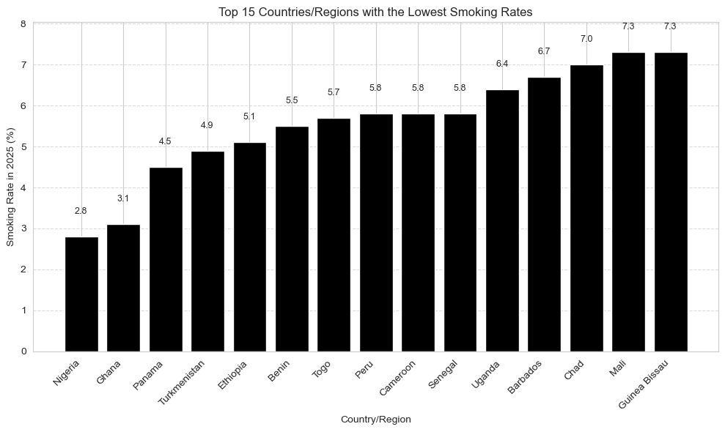
These 2 charts were very useful for me to plot because they provide a clear, descending ranking of smoking prevalence across different geographical locations. For other country-based hypotheses I considered the extreme regions here for comparison. It is seen that Nauru has the highest smoking rate at 46.7%, nearly half the population. Low smoking rates are most prevalent in certain African and Central American nations.

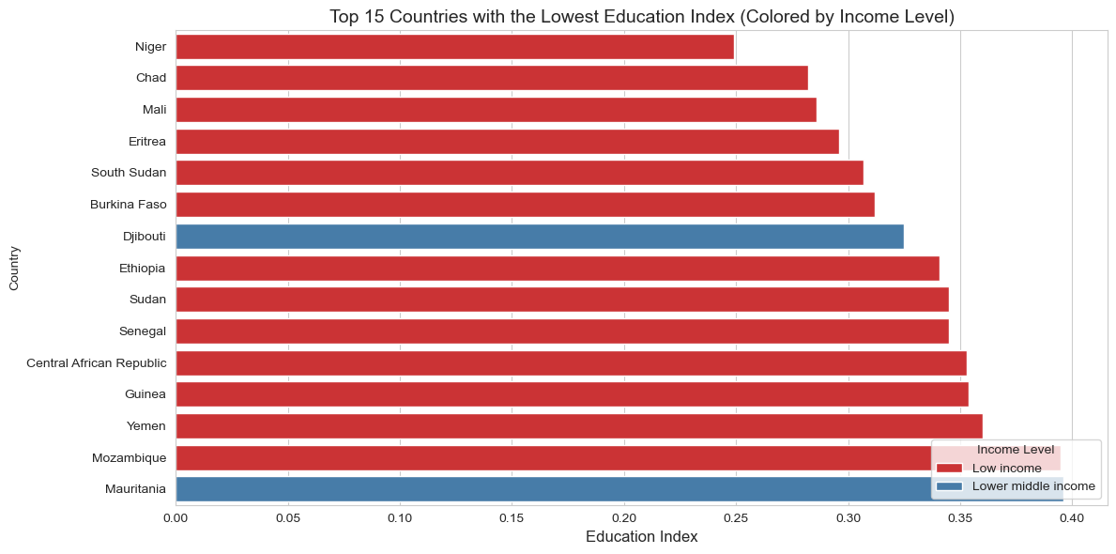
I used these chart to see if low income level or low education level is a key indicator in smoking rate of countries or not.
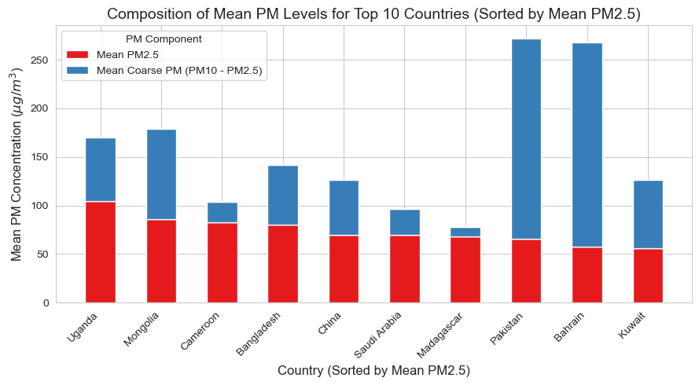
This shows the total PM10 concentration while breaking it down into its components: fine particles (PM_{2.5}) and coarse particles (PM_{10} - PM_{2.5}). Key Observation: Pakistan and Bahrain have the highest total PM concentrations, largely driven by "Coarse PM" (likely dust or sand). In contrast, Uganda has a much higher proportion of PM_{2.5} (fine particles), which are often more dangerous to respiratory health.

2-Boxplots
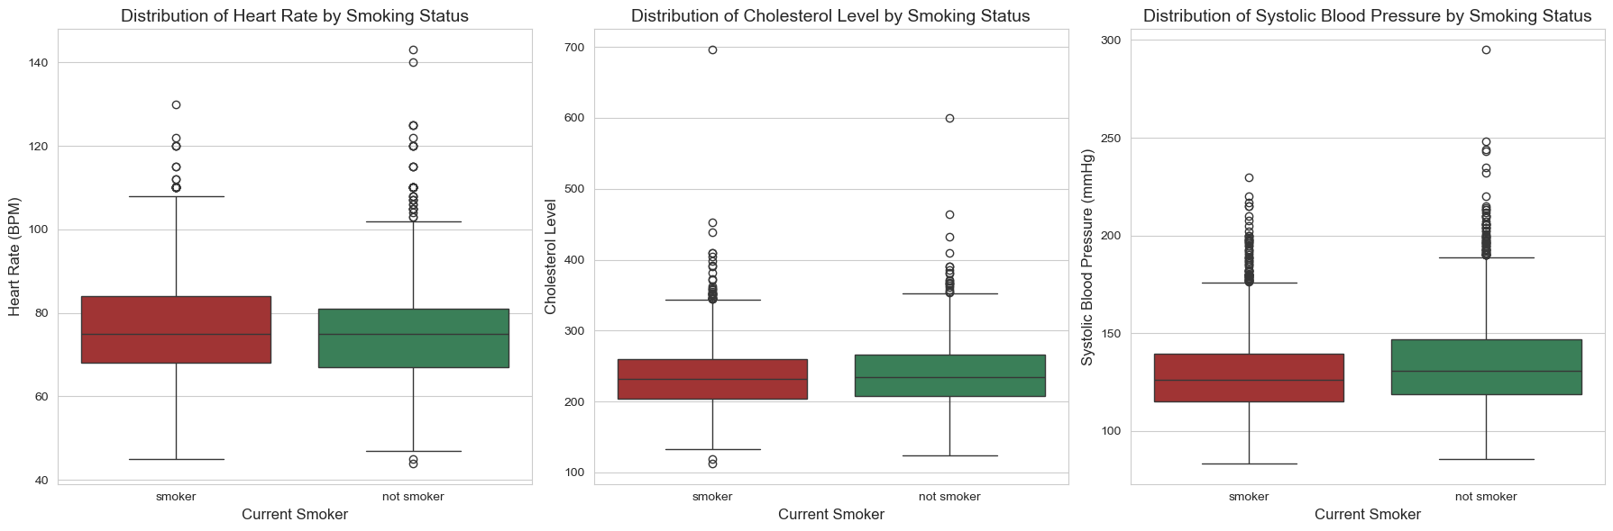Here box plots are very useful for these 3 health metrics because they provide a comprehensive view of data distribution, median, interquartile range, and outliers can be observed. While the median heart rate is slightly higher for smokers, the distributions for cholesterol and systolic blood pressure are surprisingly similar across both groups, with non-smokers actually showing a wider range of high blood pressure values. The plots effectively reveal extreme outliers indicating that high-risk health profiles exist regardless of smoking status in this dataset

3- Scatter Plots
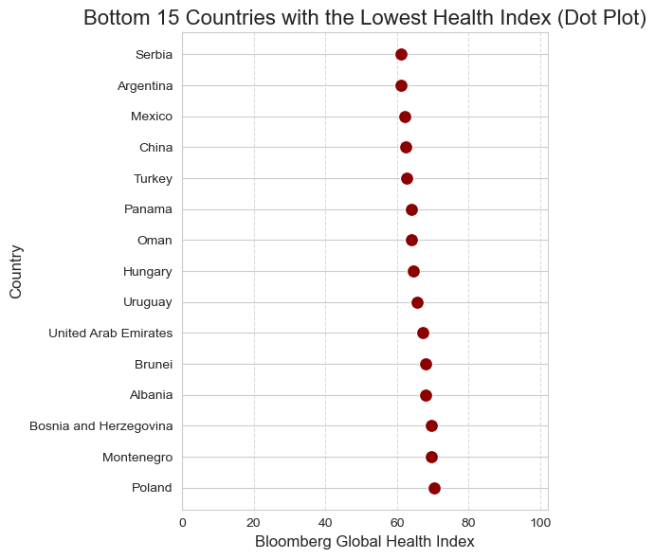
These visualization provide a detailed analysis of global health rankings. Lowest Bloomberg Global Health Index, identifying Serbia, Argentina, and Mexico as having some of the lowest scores. I wanted to test if this low health indexes caused by high smoking rate. Overall, these chart reveal the full spread of health data and the specific geographical disparities in global wellness.
4- Time-Series Plots
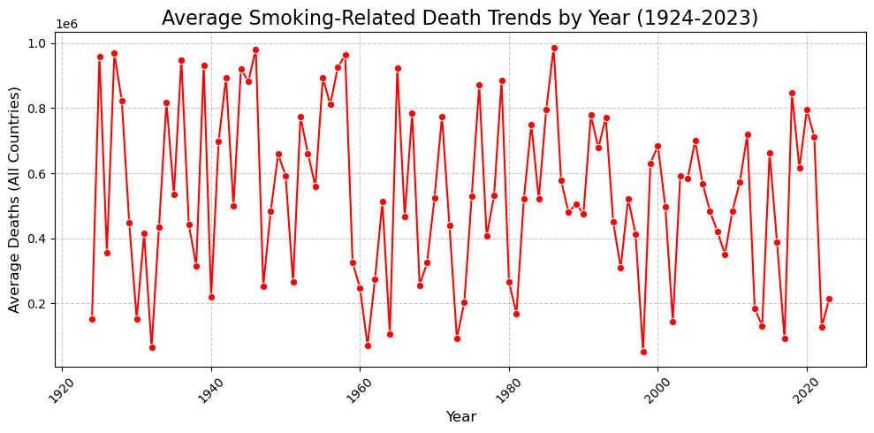
This chart tracks the average number of deaths attributed to smoking across all countries from 1924 to 2023. While there is no single smooth curve, there is a slight overall downward trend in the "peaks" starting after the year 2000, though the data remains extremely unstable.
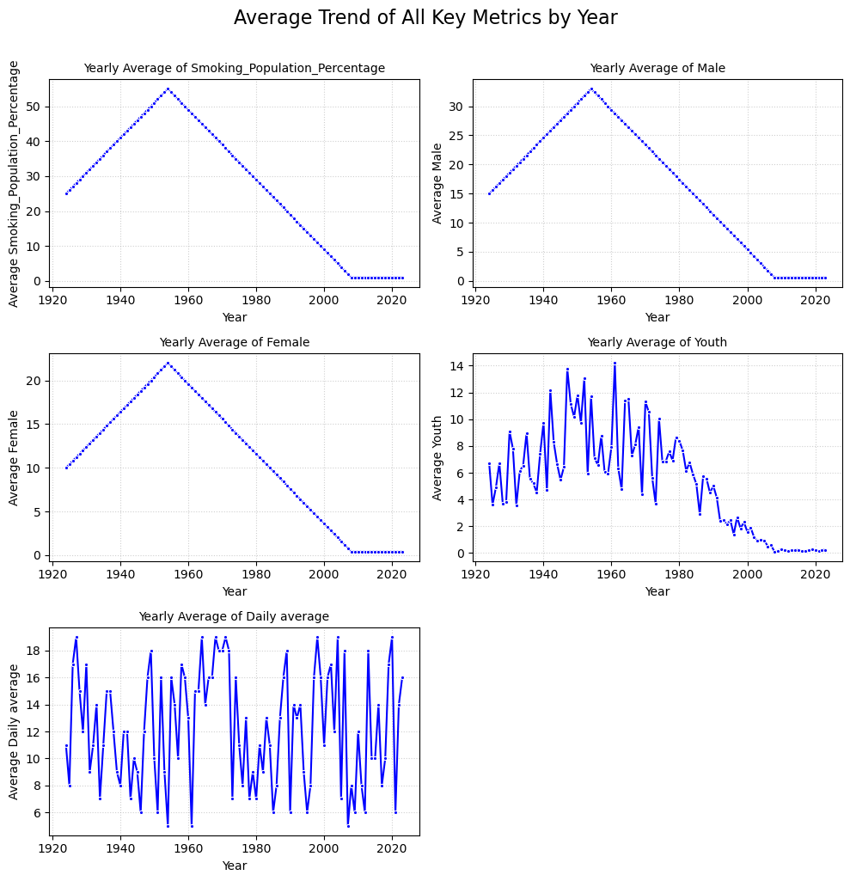•
This multi-Line Chart tracks five different smoking-related metrics. All show a sharp "pyramid" trend, peaking around 1955-1960 and then steadily declining to near zero by 2010.Youth smoking plot shows a more volatile but generally similar bell-curve trend, peaking in the 1960s. Daily Average plot shows high volatility with no clear upward or downward long-term trend, fluctuating between 5 and 19 units throughout the century.

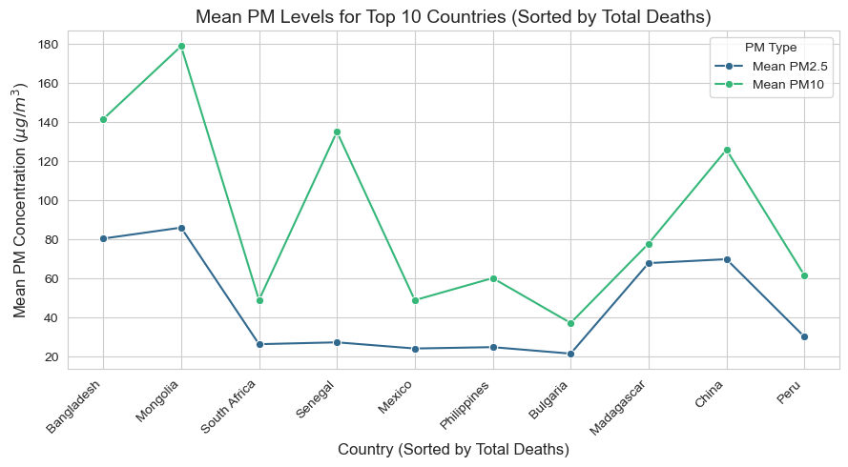
Two types of air pollution—PM2.5 and PM10—across 10 specific countries are present. It illustrates that Mongolia has the highest concentrations of both PM10 and PM2.5. It highlights the gap between the two types of particulate matter; PM10 levels are consistently higher than PM2.5 levels in every country shown. Bulgaria shows the lowest mean levels among the countries listed in this specific group.
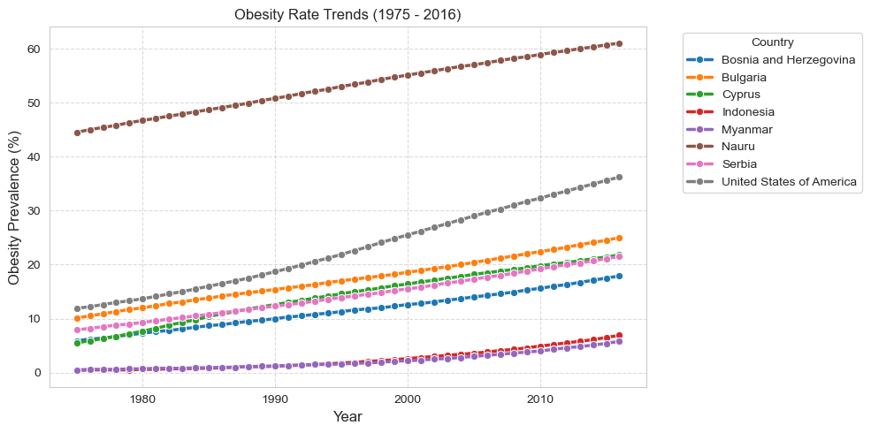
All the countries shown in the graph have seen an unfailing increase in obesity rates from 1975 to 2016. Highest Rate: Nauru. It was around 45% in 1975, rising to over 60% in 2016.Fastest Increase: USA. It was initially at a moderate level, has shown one of the steepest increases over time, reaching over 35%.

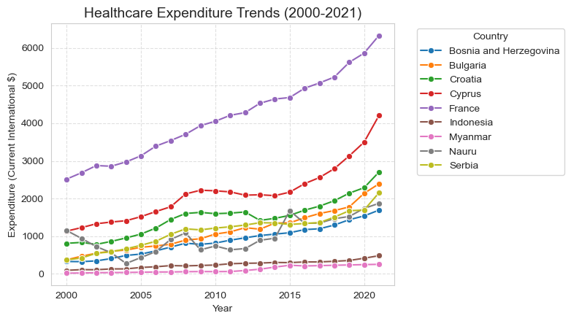
The series illustrates a universal upward in medical spending across all featured nations over two decades. France stands out as the significant outlier with the highest expenditure. While most countries like Cyprus, Croatia, and Bulgaria show steady, moderate growth, several nations including Myanmar and Indonesia maintain consistently low spending levels. Nauru exhibits the most erratic behavior with significant fluctuations in its spending patterns compared to the smoother trends seen in European nations.
5- Pie Chart
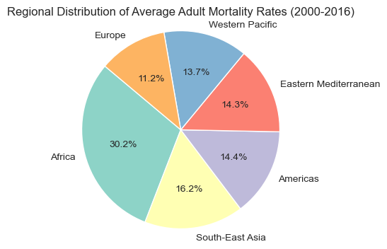
According to the pie chart of regional adult mortality rates (2000-2016), Africa has the highest share at 30.2%, while Europe represents the lowest share at 11.2%. Other regions show similar distributions between 13.7% and 16.2%.
6- Machine Learning Analysis / Linear Regression Models
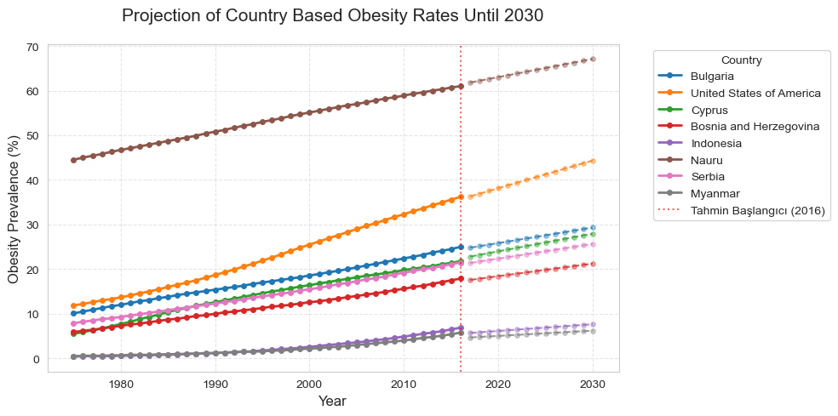
R^2 Score= 0.9015553127992556
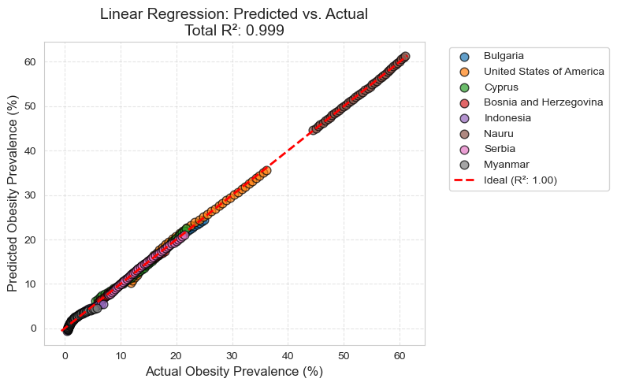High correlation
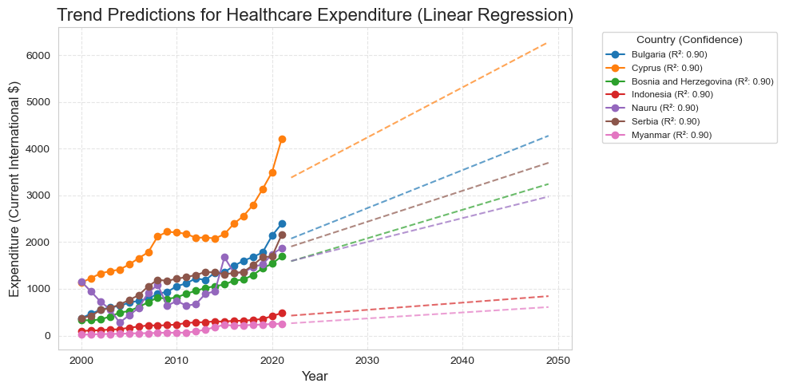
R^2 score= 0.8833609844369733
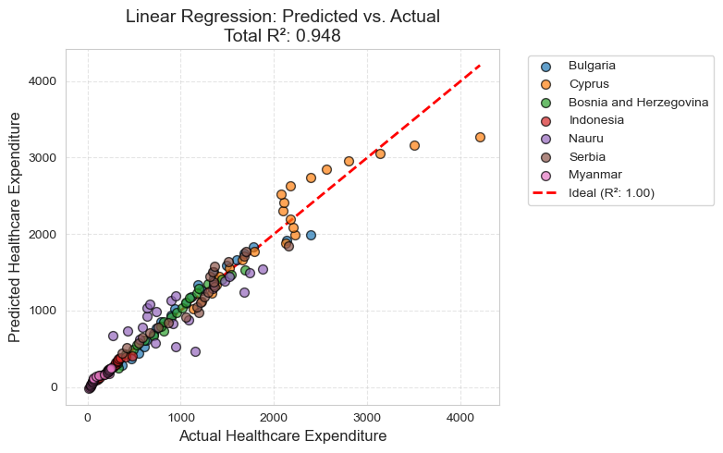
High correlation

● Overall Interpretation & Conclusion
Taken together, what stands out that smoking is strongly associated with worse health outcomes, higher mortality, environmental degradation, and broader public health risks. Even where smoking rates stabilize or decline, the long-term consequences persist.
While this project focused on empirical patterns rather than causal mechanisms, the results highlight smoking as both a medical and structural issue, opening the door for future research on policy, regulation, and prevention strategies.

● Limitations:
- Some datasets provided national averages which may mask significant regional disparities within countries.
- While the death trends dataset is longitudinal, some health metric data were cross-sectional, limiting the ability to track individual health changes over time.
● Future Work:
Future research could build on this study by using longitudinal data to explore how changes in smoking prevalence over time impact national healthcare expenditures and mortality rates. Adding variables like tobacco taxation policies, anti-smoking legislation strength, or long-term e-cigarette usage trends could also deepen the analysis.
● References:
- Kaggle: Smokers Health Data & Smoking Related Deaths Datasets.
- World Bank/WHO: Annual Healthcare Expenditure & Global Health Data.
- Our World in Data: Education and Income Level Statistics.

